IAG DENUCHANGE Workshop

Field trip

Dates: 8-9 October 2026

Day 1 | Departure: 09:00
Thursday  8/10/2026 | Transition to Aplomata
Thursday  8/10/2026 | Aplomata, landslide hazard  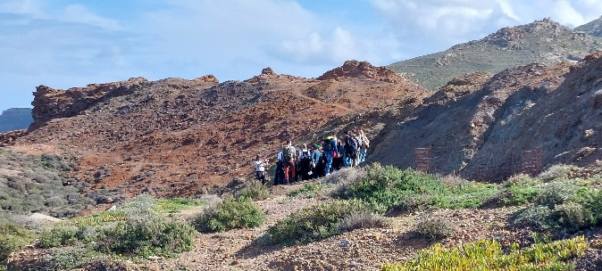
Thursday  8/10/2026 | Transition to Faneromeni Dam
Thursday  8/10/2026 | Faneromeni Dam ++++  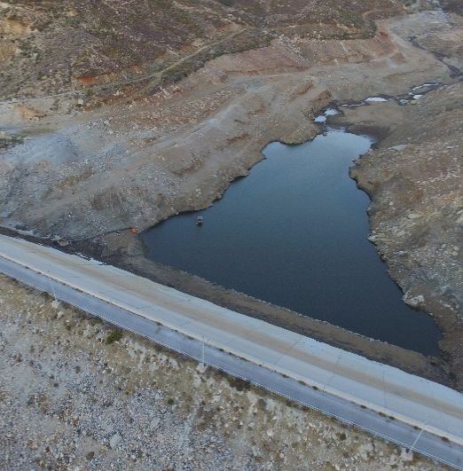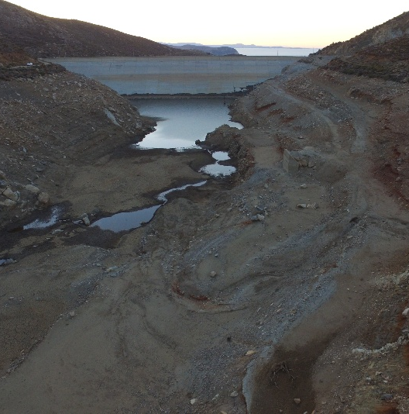
Thursday  8/10/2026 | Transition to Kinidaros
Thursday  8/10/2026 | Kinidaros area has been affected by forest fires. We will discuss the impact of fires on the landscape, erosion processes, etc.  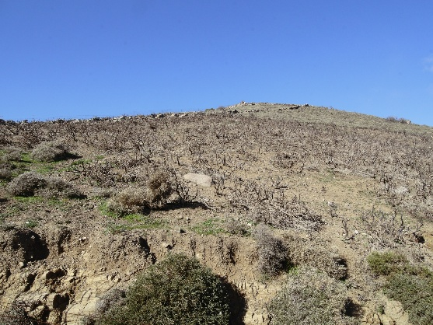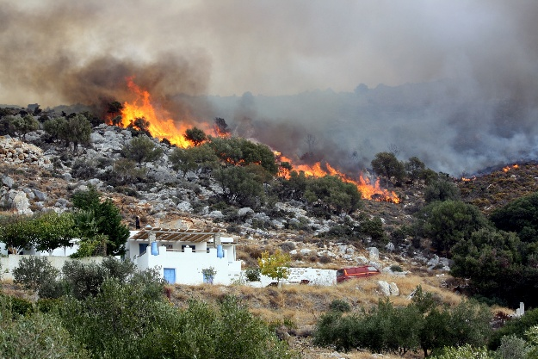
Thursday  8/10/2026 | Transition to Apeiranthos
Thursday  8/10/2026 | Geological Museum of Apeiranthos.  Apeiranthos is small mountainous village in the center of Naxos. Participants will be guided to the Geological Museum of Apeiranthos, where they will have the chance to get an introduction to the geological, geomorphological, and palaeogeographical history of Naxos, and visit an emery mine – virtually.  https://www.naxos.gr/geological-museum-of-apeiranthos/?lang=en  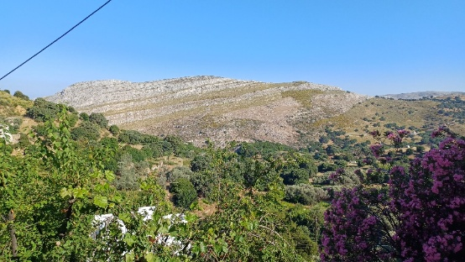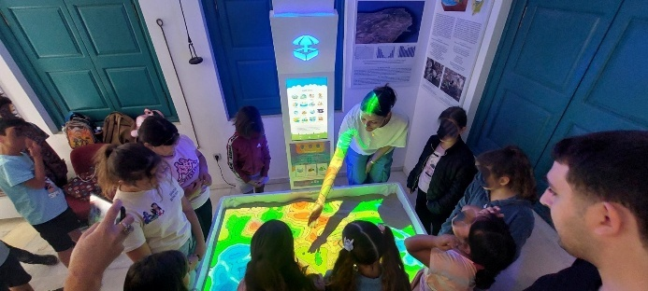

Day 2 | Coastal processes  Meeting time: 09:00
Friday  9/10/2026 | Transition to Laguna
Friday  9/10/2026 | At Laguna, students will discuss the local geomorphology, including the palaeogeographical evolution of the area, which factors affected it, and learn how we have reconstructed it. During Antiquity, Laguna used to be a bay, used as a harbor to access the nearby temple of Dionysus at Yria site. Furthermore, they will see the granodiorite of Naxos. They will discuss how it is formed and what its composition is. Also, they will get to see spectacular honeycomb weathering formations, the so-called tafoni, which are typical landforms on crystalline rocks such as the granodiorite. Moreover, they will see aeolianites and they will analyze how they are formed. In this area, the aeolianites have been partly quarried during ancient times, and this will also help them get a further idea of the area’s palaeogeographical regime. They will also observe beachrocks and become familiar with their formation processes. They will understand how beachrock protects the shore from coastal erosion, and how coastal protection can be achieved by simply mimicking what nature does, instead of applying hard engineering, such as the building of sea walls and groynes.  - Sand dunes and coastal lagoons  - Nature-based solutions to cope with coastal erosion - The role of beachrocks for coastal protection  - Nature-based solutions to restore sand dunes  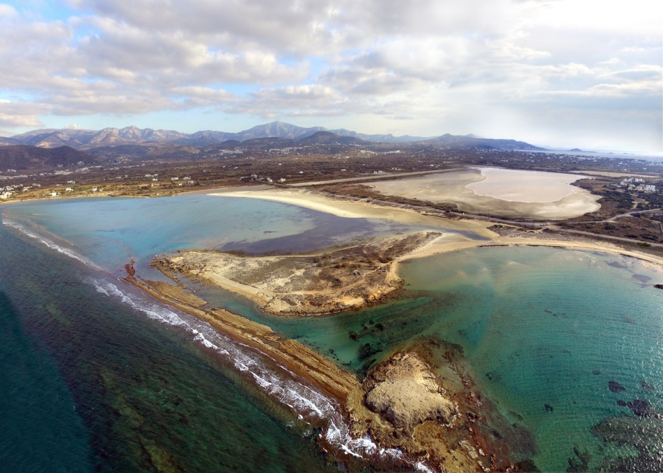
Friday  9/10/2026 | Transition to Stelida
Friday  9/10/2026 | Tafoni, weathering processes
Friday  9/10/2026 | Transition to Mikri Vigla
Friday  9/10/2026 | - Protection of coastal vulnerable environments  - Climate change and Sea level rise  ++++ photo
Friday  9/10/2026 | Transition to Pyrgaki
Friday  9/10/2026 | At Pyrgaki, majestic sand dunes have formed around the beach. Some of these dunes are taller than 5 m.  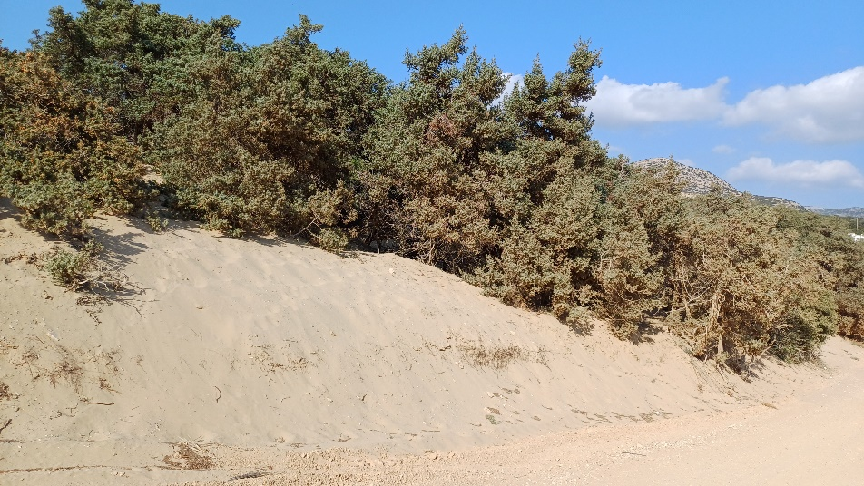
Friday  9/10/2026 | Transition to Alyko
Friday  9/10/2026 | Alyko is a sandy pocket beach located at the front of a steep coastal cliff. At Alyko, we will discuss coastal processes of a pocket beach, cliff retreat and coastal erosion.  Alyko is a sandy pocket beach located at the front of a steep coastal cliff. At Alyko, we will discuss coastal processes of a pocket beach, coastal erosion and methods used to assess erosion rates. GNSS-RTK will be used to perform topographic cross sections and coastline change.  